**PROJECT REPORT**

HR Analytics

**Project Title** – HR Analytics (Employee Attrition Analysis)

**Technology** – Power Bi

**Tools-** Power BI Visualization Tools

* **Introduction:**

Employee attrition is a critical factor in shaping the long-term success and sustainability of an organization. High attrition rates can lead to increased recruitment costs, loss of talent, and disruptions in operations. This report delves into the attrition patterns of employees within the company, focusing on various influencing factors such as tenure, age, job role, education, salary, and gender. By analyzing these attrition trends, the company can identify key areas where retention strategies can be improved, ultimately leading to a more stable and engaged workforce.

##### **Attrition by Year at Company**

**Attrition Breakdown:**

* **First Year:** 59 employees
* **Second Year:** 27 employees
* **Third Year:** 20 employees
* **Fourth Year:** 19 employees
* **Fifth Year:** 21 employees
* **Ten Years:** 18 employees

**Insight:** Attrition is highest in the **first year** of employment, which is often the most critical period for new hires. This suggests that the company may face challenges in effectively onboarding employees or meeting their initial expectations. Attrition rates decrease as employees spend more years with the company, but there is still a noticeable level of turnover even after five years. A closer look at the onboarding and support process for new employees may help reduce first-year attrition.

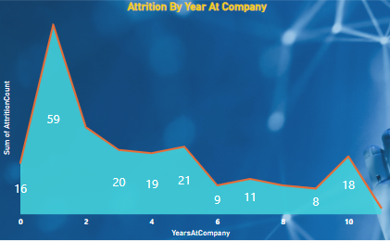

##### **Attrition by Age Group**

**Attrition Breakdown:**

* **18-25 Age Group:** 44 employees
* **26-35 Age Group:** 116 employees
* **36-45 Age Group:** 43 employees
* **46-55 Age Group:** 26 employees

**Insight:** The **26-35 age group** shows the highest attrition rate, with 116 employees leaving. This suggests that employees in this age bracket may be seeking greater career progression, stability, or work-life balance. As individuals in this age group often experience significant life and career changes, such as starting families or seeking more responsibility, targeted retention programs focused on career development, flexible work options, and long-term career paths could help reduce turnover.

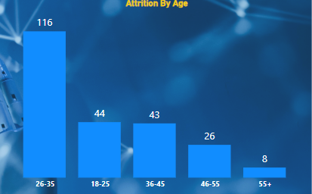

##### **Attrition by Job Role**

**Attrition Breakdown:**

* **Laboratory Technician:** 62 employees
* **Sales Executive:** 57 employees
* **Research Scientist:** 47 employees
* **Sales Representative:** 33 employees

**Insight:** The **Laboratory Technician** and **Sales Executive** roles have the highest attrition rates. This may point to potential dissatisfaction or a lack of career growth opportunities in these positions. The company should explore offering career development programs, mentorship, and better compensation packages for these roles to improve retention.

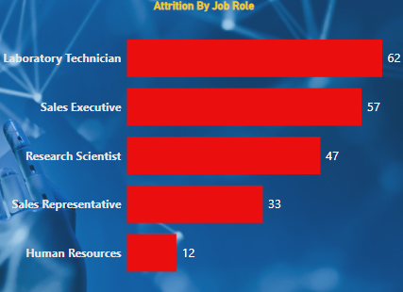

##### **Attrition by Salary Slab**

**Attrition Breakdown:**

* **Up to 5k:** 163 employees
* **5k-10k:** 49 employees
* **10k-15k:** 20 employees
* **15k+:** 5 employees

**Insight:** The highest attrition rate occurs in the **Up to 5k** salary slab, with 163 employees leaving. This indicates that employees in this salary range may be more likely to seek higher-paying opportunities elsewhere. The company should consider reviewing its compensation packages, providing salary reviews, and exploring non-monetary benefits such as career development programs to enhance employee satisfaction and retention within this salary range.

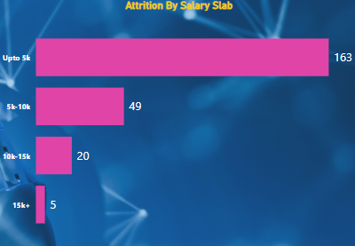

##### **Attrition by Gender**

**Attrition Breakdown:**

* **Male:** 140 employees
* **Female:** 79 employees

**Insight:** There is a higher attrition rate among **male employees** compared to females. This could be due to various factors, including job satisfaction, career progression, or personal circumstances. The company should investigate further into male-specific challenges or disparities in job satisfaction and ensure that both male and female employees receive equal support, growth opportunities, and work-life balance policies.

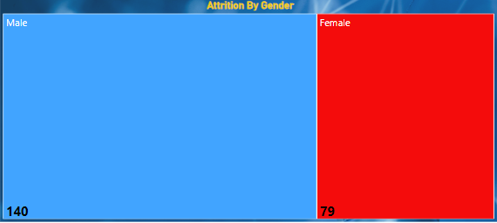

### **Attrition by Education:**

**Attrition Breakdown:**

* **Life Sciences: 89 employees**
* **Medical: 63 employees**
* **Marketing: 35 employees**
* **Technical Degree: 32 employees**

### **Insight:**

* **Life Sciences** has the highest attrition (89 employees), indicating potential external competition. Focus on career growth and specialized training could help retain talent.
* **Medical** field shows significant attrition (63 employees), suggesting the need for better compensation and career development opportunities to retain employees.
* **Marketing** (35 employees) and **Technical Degree** (32 employees) fields have lower attrition, but retention efforts should still focus on skill development and career progression to further reduce turnover.

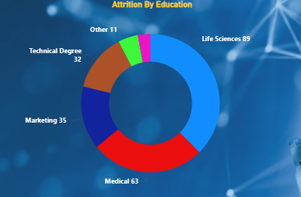

#### ****Conclusion:****

The analysis of attrition patterns provides valuable insights into the key drivers of employee turnover within the company. High attrition rates in the **first year**, **26-35 age group**, **Laboratory Technicians**, **Sales Executives**, and **employees in lower salary slabs** highlight areas that need immediate attention. By implementing targeted retention strategies such as improved onboarding processes, career development opportunities, competitive compensation packages, and work-life balance initiatives, the company can reduce attrition and foster a more engaged and satisfied workforce.